Atoms can gain energy from other particles when a free electron collides with an electron in the atom’s shell.

If the energy from the free electron is at the correct level, the electron from the shell will be knocked off the atom, thus ionising the atom.

If the energy is insufficient for the atom, the electron in the shell can be promoted to another, higher shell. This is known as excitation.

Alpha, beta, and gamma particles, as well as neutrons, can be ionising.

Measuring ionisation energy

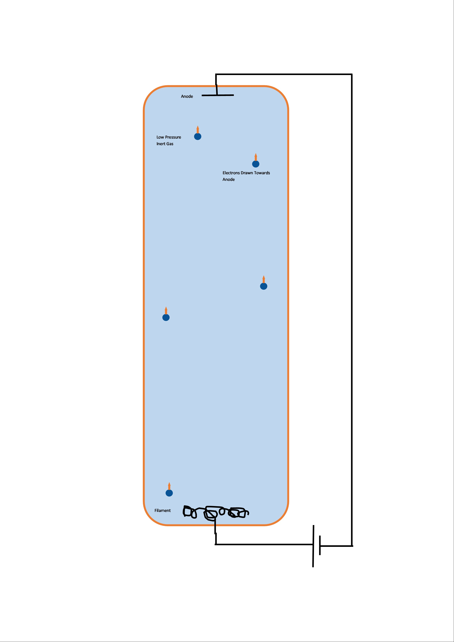
- Electrons are released by the heating filament.
- Electrons are attracted to the anode
- Moving electrons pass through the gas.
- The current between the anode and filament slowly increases.
- As the current increases, the electrons gain more energy.
- This causes the gas to ionise, as the energetic electrons knock more electrons from the gas.
- If a large jump in current is detected, the gas is ionised, as the ions can carry the charge between the filament and the anode.

The work done on each electron is equal to the charge * the voltage. This means that the work done is equal to the electron energy in eV.
Excitation

We can measure excitation with the same equipment as above.

Instead of a current spike, a current drop is experienced.
This is because when the electron collides with the atom, the free electron loses energy, so less electrons reach the anode. This causes a lower current than before.

Energy levels in atoms

Energy levels closer to the nucleus are at a lower energy than levels further away.

Energy levels are numbers from 1, where 1 is closest to the nucleus, or the ground state.

An electron is in an excited state when it is in a higher energy shell than before.

If the electron is excited, it will fall back down to the original energy level, where it is most stable. This results in a photon being released, with the energy of the particle that originally excited it.

De-excitation can occur in one large step (e.g. level 5-1), or in many steps (e.g. level 3-2, then 3-1).

Electrons can jump any number of levels, as long the correct amount of energy is supplied.

The energy supplied to the electron to excite it must be almost exactly the correct amount of energy, as if the energy is too high or too low, the electron will only heat up, not excite.

